Healthy Recipe Contest Directions:

Before event:
- Secure a date, time and location for your event
- Arrange for a place where the contest contestants can leave their dishes until time of event – let contestants know
- Prepare promotion materials - promote a minimum of 3 weeks before event to get contestants/ 2 weeks before event to announce contest to faculty and staff
- Get copies of recipes from contestants – make copies
- Have enough tables to hold all the dishes being brought – have table clothes if you want
Day of Event:
- Have food set up at least 20 minutes before start of event
- Leave recipes copies by dishes (or format that is most convenient for your situation)
- As people arrive, give them 3 tickets – let them know they are voting on the recipes. They will drop tickets in the bucket of their top 3 choices.
- Give people about 30 minutes to try the different dishes
- 10 minutes before count tickets – announce that votes need to be placed because the tally will take place in 10 minutes for the top 3 recipes
- Provide the top 3 winners with a prize

Materials needed:
- Small buckets or baskets for each dish for the voting process (check with the art teacher)
- Raffle tickets (or anything comparable) that faculty/staff can use for voting
- Prizes
- Paper plates, spoons, forks, knives, cups (you could ask contestants to help provide these)

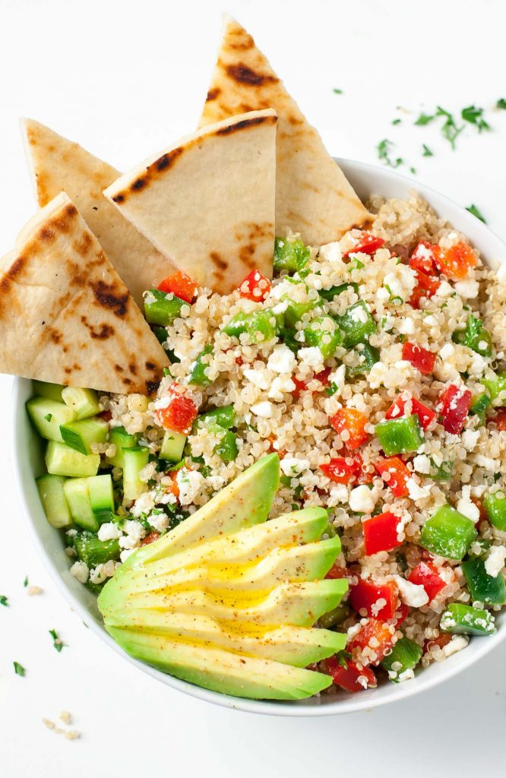
This Photo by Unknown Author is licensed under CC BY-NC-ND
Healthy Recipe Contest

Do you have a delicious healthy recipe you would like to share?

Bring your prepared dish and be part of the contest. The faculty and staff will have a chance to try all the delicious recipes and vote on their top 3 favorites.

Please let me know by ___________________________ if you want to bring a healthy dish to share.
- On the day of the event you may leave your dish in the __________________________ until we have the contest
- If you are able, please provide plates, eating utensils, cups for your dish
- Please be available to help set up and clean up – THANKS!!

Thank you

Your name
Email

This Photo by Unknown Author is licensed under CC BY-NC-ND
Healthy
Recipe
Contest

Do you want to try some new healthy recipes?
Your co-workers are sharing some of their favorite dishes and you get to vote for your top 3 favorites.

Stop by, try some new dishes and support your co-workers!!
Date:
Time:
Location:

