Let’s practice healthy habits during the month of *********. Each day of the week will focus on an area of wellness. Suggestions of healthy activities are provided for each day of the week.
Complete 1 or more of the activities each day of the week.
Well-Being Month
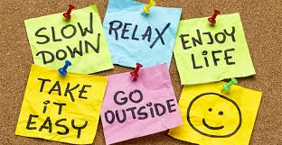
Questions?
Add your contact info here
Fridays – Your Choice
- Pick from the weekly activities or do something different; just keep it healthy

Thursdays: Self-Care
- Enjoy lunch with a co-worker – don’t talk about work
- Write down 3 things you are grateful for
- ******* (need another idea)

Wednesdays: De-Stress
- Take 5-10 deep breaths when feeling stressed
- Go outside for a few minutes
- Watch a funny video about animals
Tuesdays: Stay Active
- Take a walk during your break or lunch
- Walk instead of calling or emailing
- Get up and stretch each hour
Mondays: Eat healthy
- Start your day with a healthy breakfast
- Bring a healthy lunch to eat at work
- Eat fruits and vegetables instead of unhealthy snack

Wellness-Being Month
Name ____________________________________________

Directions: Keep track of the activities you do each day of the week during the month of **************. Mark each day to engage in well-being activities.
Fill in with dates

Sun | Mon | Tues | Wed | Thurs | Fri | Sat

Turn in your completed tracker to ************ by ******************. Each employee who turns in a tracker will be eligible to win some prizes.
- Make a list of your prizes

