Deltona High Healthy Recipe Book
Submitted by Julia Carson, Wellness Champion Deltona HS
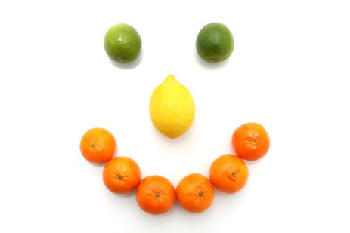
Do you have a healthy recipe you would like to share – just in time for the holidays?
We are collecting your favorite HEALTHY recipes to create a Deltona High Healthy Recipe Book.
All recipes need to follow the format below – please type them and if possible, include a picture of the dish.
Categories Include:
Breakfast/Brunch
Main Dishes
Salads/Soups
Vegetarian Dishes
Side Dishes
Desserts
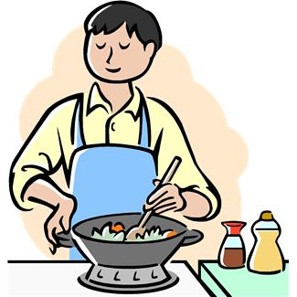

Due date: December 12 to Julia Carson through email.
Questions? Email Julia Carson, Deltona High Wellness Coordinator

Deltona High 2020 Recipes
picture

Category________________________________________________________
Recipe Name ____________________________________________________
Submitted by ____________________________________________________
Serves___________________
Ingredients___________________________________________________________________________________________________________________________________________________________________________________________________________________________________________________________________________________________________________________________________________________________________________________________________________________________________________________________________________________________________________________________________________________________________________________________________________________________________________________________________________________________________________________________________________________________________________________

Directions ________________________________________________________________________________________________________________________________________________________________________________________________________________________________________________________________________________________________________________________________________________________________________________________________________________________________________________________________________________________________________________________________________________________________________________________________________________________________________________________________________________________________________

