Healthy Recipes Cookbook
Submitted by Yahaira Lopez, Osceola ES Wellness Champion
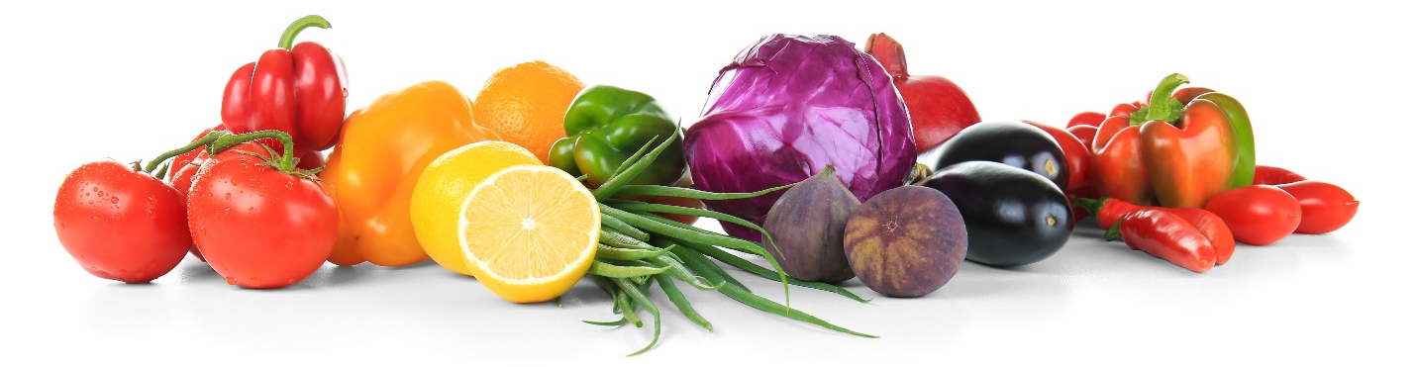

It's time to FALL into HEALTHY Recipes!!

Do you have delicious healthier recipes that people praise you on? A healthy spin on lasagna or a healthier "Taco Tuesday" recipe? Would you be willing to share your recipe with your Osceola Family?

During the month of November, please send Ms. Lopez a healthy recipe to share with the faculty and staff. We will put them all together in a digital platform so everyone can access it to try some new healthier recipes. With the Thanksgiving season upon us, this will be the perfect opportunity to live the mantra "sharing is caring".

Please be sure to send your recipes via email by November 30th. Happy sharing! 🙂"

